Assignment4 Report D1262075

**IQueue.cpp:**

first define head and tail in IQueue. Then write enqueue to inserts a new element at the end of the queue. It dynamically allocates memory for a new node, assigns its data and pointers, and updates the tail pointer accordingly. The write deqeue to delete elements in the front of the queue, and update head node to yhee next node after the previous been removed. Then get size of the queue using count to go through the whole queue. Lastly print the queue from head to tail, return to a new line once the previous line existed 20 elements.

**IQueueMain.cpp:**

Use ‘IQueue Q;’ so that Q can be used to access all members define in class IQueue. Then randomly generate trail count from 1 to 10. Lastly use for loop and std::cout to print out enqueue and dequeue series.

**Node.cpp:**

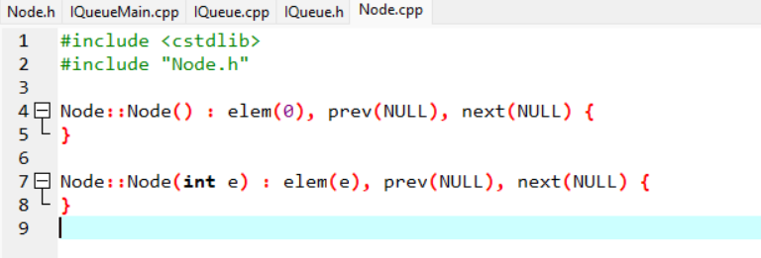

This code is use to define two constructors functions for the class ‘Node’.

In the first constructor, initialize the ‘elem’ member to 0, then initialize the ‘prev’ and ‘next’ members to NULL.

In the second constructor, initialize the ‘elem’ member to the value of the parameter ‘e’. then initialize the ‘prev’ and ‘next’ members to NULL.